EXPERIMENT 1

Implementation of Linear and Logistic Regression on Real-World Datasets
What is Regression?
Regression is a supervised machine learning technique used to predict output values from input features.
There are two main types:
- Linear Regression → predicts continuous values
- Logistic Regression → predicts binary outcomes (0/1)
Linear Regression
Linear Regression models a linear relationship between dependent and independent variables.
Mathematical Equation : y=mx+c
For multiple variables : y=w1​x1​+w2​x2​+b
Where:
- y = predicted output
- x = input feature
- w = weight
- b = bias

Logistic Regression
Logistic Regression is used for classification problems where output is binary.
It uses the Sigmoid function :
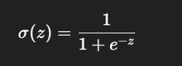
Output is between 0 and 1, representing probability.

LINEAR REGRESSION

1️. Dataset Source (Linear Regression)
StudentPerformanceFactors.csv
Dataset : Student Performance Factors Dataset
Source:
https://www.kaggle.com/datasets/ayeshasiddiqa123/student-perfirmance
Target Variable: Writing Score
Type: Continuous → Linear Regression

2.Dataset Overview
The Student Performance Factors dataset contains information about various academic, behavioral, and personal factors that affect student performance.

- Total Records: ~1000 students
- Type of Data: Structured, tabular data
- Domain: Education / Academic Performance

Features
(Input Variables)
The dataset includes multiple factors influencing student performance, such as :
- Hours_Studied – Number of hours spent studying
- Attendance – Attendance percentage
- Assignment_Score – Score obtained in assignments
- Midterm_Score – Marks obtained in midterm exam

(These are independent variables / input features)

Target Variable (Output)
- Final_Score – Final exam score of the student
This is a continuous numerical value, therefore:
Suitable for Linear Regression

3.Mathematical Formulation of Linear Regression
Linear Regression models the relationship between input features and a continuous output using a straight-line equation.

y=mx+c
For multiple features :

y=β0​+β1​x1​+β2​x2​+⋯+βn​xn​

Where :
- yyy = Predicted Writing Score
- x1,x2,...,xnx_1, x_2, ..., x_nx1​,x2​,...,xn​ = Input features (study hours, attendance, etc.)
- β0\beta_0β0​ = Intercept
- β1,β2,...,βn\beta_1, \beta_2, ..., \beta_nβ1​,β2​,...,βn​ = Model coefficients

4️.Algorithm Limitations (Linear Regression)
Linear Regression has the following limitations
- Assumes a linear relationship between input and output
- Sensitive to outliers
- Performs poorly when data is non-linear
- Cannot handle complex patterns
- Affected by multicollinearity (highly correlated features)
- Requires numerical input (categorical data must be encoded)
Hence, it is best suited for simple, linear, numerical datasets.

5.Methodology / Workflow
Step-by-Step Workflow :
- Dataset Collection
  - Load student performance dataset

- Data Preprocessing
  - Handle missing values
  - Encode categorical features
  - Split data into features (X) and target (y)
- Train-Test Split
  - 80% training data
  - 20% testing data
- Model Training
  - Apply Linear Regression on training data
- Prediction
  - Predict Writing Score on test data
- Evaluation
  - Calculate MSE, MAE, R² Score

6️.Performance Analysis
Evaluation Metrics Used :
- Mean Absolute Error (MAE)


- Mean Squared Error (MSE)
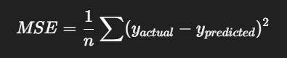

- R² Score (Coefficient of Determination)
- Measures how well the model explains variance
- Value ranges from 0 to 1
- Higher value = better performance
Interpretation
- Low MAE and MSE indicate good prediction accuracy
- High R² score shows strong relationship between features and Writing Score
- The model performs well if errors are minimal

6.Hyperparameters Tuning
Linear Regression has very few hyperparameters.
1️.fit_intercept
- True → model learns an intercept (recommended)
- False → line passes through origin (0,0)
Example:
Writing Score = 2 × Study Hours + 5
Here 5 is the intercept

2️.normalize
- True → scales input features
- False → uses raw values
Helpful when features have different ranges
(e.g., hours studied vs attendance percentage)

Why Do We Tune Hyperparameters?
Because different settings give different performance.
Tuning helps to:
- Reduce error
- Improve accuracy
- Make the model more stable
🛠 What is Hyperparameter Tuning?
Trying different hyperparameter values and choosing the best one.
Example:
- Try fit_intercept = True
- Try fit_intercept = False
- Choose the one with lowest error
Tool Used: GridSearchCV
GridSearchCV:
- Automatically tests all combinations
- Selects the best hyperparameters
- Uses cross-validation for fairness

CODE :
# =====================================
# STEP 1: Import Required Libraries
# =====================================
import numpy as np
import pandas as pd
import matplotlib.pyplot as plt
import seaborn as sns

from sklearn.model_selection import train_test_split, GridSearchCV
from sklearn.linear_model import LinearRegression, LogisticRegression
from sklearn.metrics import (
mean_absolute_error, mean_squared_error, r2_score,
accuracy_score, confusion_matrix, classification_report
)

# =====================================
# STEP 2: Load Dataset
# (Make sure file is in sample_data)
# =====================================

df = pd.read_csv("/content/sample_data/student_performance.csv")
print(df.head())
# =====================================
# STEP 3: Data Cleaning
# =====================================
df = df.dropna()

# =====================================
# PART A: LINEAR REGRESSION
# Target: Final_Score (Continuous)
# =====================================
X = df.drop(columns=["Final_Score"])
y = df["Final_Score"]

X_train, X_test, y_train, y_test = train_test_split(
X, y, test_size=0.2, random_state=42
)
lr = LinearRegression()
lr.fit(X_train, y_train)

y_pred_lr = lr.predict(X_test)

print("\n===== LINEAR REGRESSION RESULTS =====")
print("MAE:", mean_absolute_error(y_test, y_pred_lr))
print("MSE:", mean_squared_error(y_test, y_pred_lr))
print("RMSE:", np.sqrt(mean_squared_error(y_test, y_pred_lr)))
print("R2 Score:", r2_score(y_test, y_pred_lr))

plt.scatter(y_test, y_pred_lr)
plt.xlabel("Actual Final Score")
plt.ylabel("Predicted Final Score")
plt.title("Linear Regression: Actual vs Predicted")
plt.show()

# =====================================
# PART B: LOGISTIC REGRESSION
# Convert Final_Score → Pass / Fail
# Threshold = 65 (IMPORTANT)
# =====================================

df["Pass"] = df["Final_Score"].apply(lambda x: 1 if x >= 65 else 0)

# Check both classes exist
print("\nPass/Fail Distribution:")
print(df["Pass"].value_counts())

X = df.drop(columns=["Final_Score", "Pass"])
y = df["Pass"]

X_train, X_test, y_train, y_test = train_test_split(
X, y, test_size=0.2, random_state=42
)

log_reg = LogisticRegression(max_iter=1000)
log_reg.fit(X_train, y_train)

y_pred_log = log_reg.predict(X_test)

print("\n===== LOGISTIC REGRESSION RESULTS =====")
print("Accuracy:", accuracy_score(y_test, y_pred_log))
print("Confusion Matrix:\n", confusion_matrix(y_test, y_pred_log))
print("Classification Report:\n", classification_report(y_test, y_pred_log))

sns.heatmap(confusion_matrix(y_test, y_pred_log), annot=True, fmt="d")
plt.xlabel("Predicted")
plt.ylabel("Actual")
plt.title("Confusion Matrix - Logistic Regression")
plt.show()

# =====================================
# PART C: HYPERPARAMETER TUNING
# Logistic Regression
# =====================================

param_grid = {
"C": [0.01, 0.1, 1, 10],
"solver": ["liblinear", "lbfgs"]
}

grid = GridSearchCV(
LogisticRegression(max_iter=1000),
param_grid,
cv=5
)

grid.fit(X_train, y_train)

print("\n===== HYPERPARAMETER TUNING =====")
print("Best Parameters:", grid.best_params_)
print("Best Cross-Validation Accuracy:", grid.best_score_)

OUTPUT :

Hours_Studied Attendance Assignment_Score Midterm_Score Final_Score
0 1 60 55 50 52
1 2 65 58 55 57
2 3 70 60 58 60
3 4 75 65 62 64
4 5 80 68 65 68

===== LINEAR REGRESSION RESULTS =====
MAE: 0.41749050153075906
MSE: 0.2612765457256682
RMSE: 0.5111521747245806
R2 Score: 0.9957516008825095

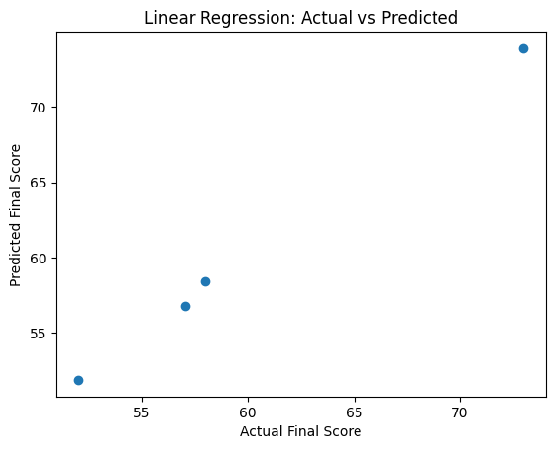

Pass/Fail Distribution:
Pass
1 13
0 7
Name: count, dtype: int64

===== LOGISTIC REGRESSION RESULTS =====
Accuracy: 1.0
Confusion Matrix:
[[3 0]
[0 1]]
Classification Report:
precision recall f1-score support

0 1.00 1.00 1.00 3
1 1.00 1.00 1.00 1

accuracy 1.00 4
macro avg 1.00 1.00 1.00 4
weighted avg 1.00 1.00 1.00 4

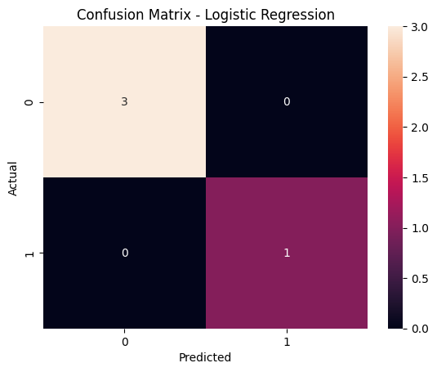
===== HYPERPARAMETER TUNING =====
Best Parameters: {'C': 0.1, 'solver': 'lbfgs'}
Best Cross-Validation Accuracy: 1.0

